**English Homework for the 8th Weekend (April 11th )**

**Class___________ Name___________**

**Requirements:**

1. 完成E听说练习作业 (要求**达标**)。
2. 自主复习U4单词短语, **闭卷完成**周末作业单（字迹端正）。

请家长提醒并监督孩子认真完成听说练习和书面作业，养成良好的作业习惯！

***Wits Corner:***

***The greatness of a nation and its moral progress can be judged by the way its***

***animals are treated. 一个国家的伟大和道德进步可以通过它对待动物的方式来衡量。***

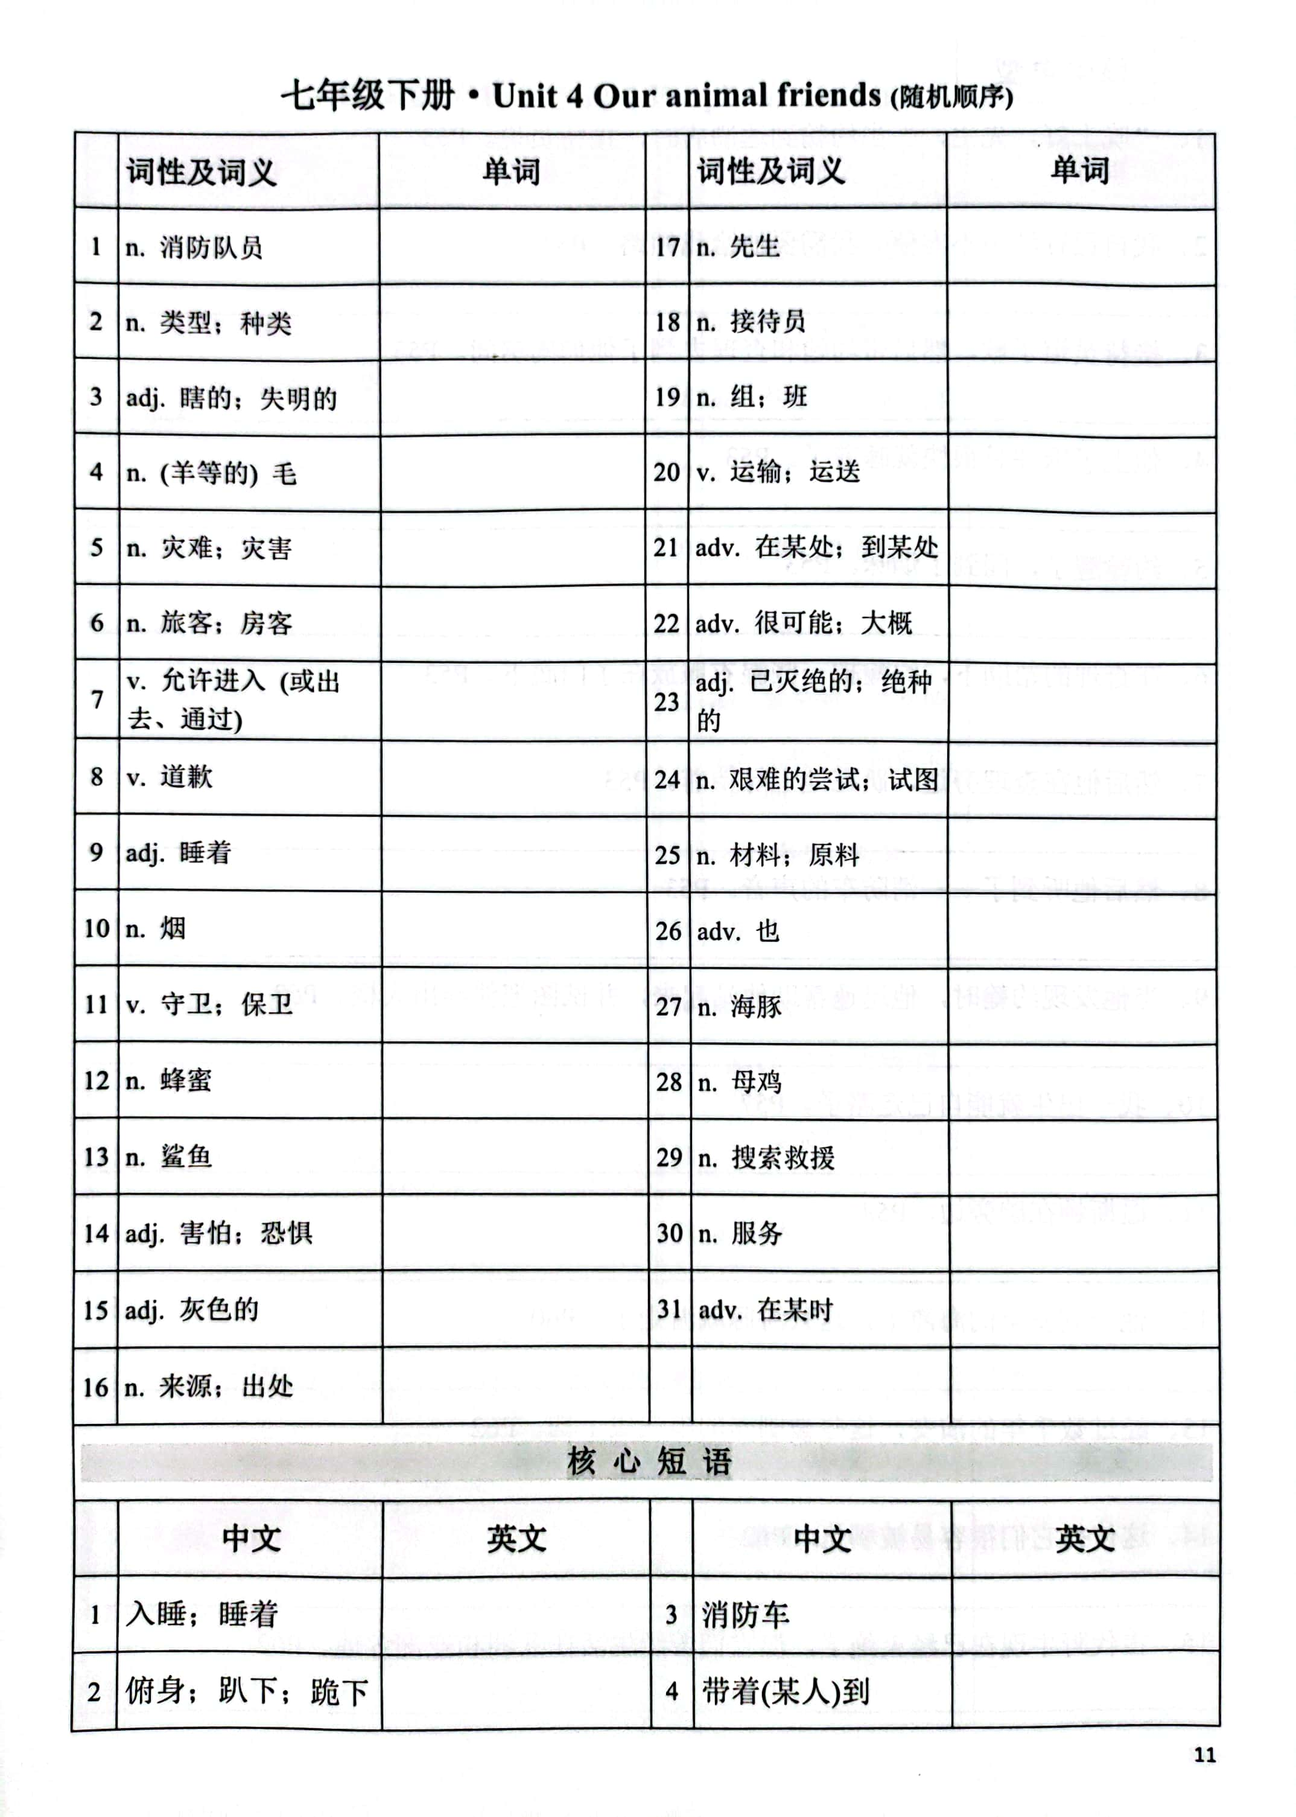**家长签名__________**



****核心句型

1、先生，欢迎您入住，但是我们这里不允许携带宠物入内。P53

____________________________________________________________________________

2、我需要他引导我走路。P53

____________________________________________________________________________

3、接待员道了歉，带着约翰和查理到他们的房间。P53

____________________________________________________________________________

4、他上床后很快就睡着了。P53

____________________________________________________________________________

5、突然，查理开始叫了起来。约翰醒了，闻到了烟味。着火了！

烟开始从门底下进来。

________________________________________________________________________________

6. 在查理的帮助下，约翰沿着门底塞了一些湿的衣物。P53

____________________________________________________________________________

7、不久，一名消防员赶到，从窗户进入了房间。P53

____________________________________________________________________________

8、他上床后很快就睡着了。P53

____________________________________________________________________________

9、最后，消防员把约翰和查理都安全地带出了大楼。P53

____________________________________________________________________________

一、根据要求写出相应的单词。

1.serve →(名词)_______________ 2. fireman→(复数) _______________

3.effort →(复数) ________________ 4.apology→(动词) __________________

5. transportation →(动词)____________ 6. sleep→(形容词) _______________

7. scare →(形容词)_________________ 8. friend→(形容词) ________________

9. possibly →(同义词)________________ 10. type →(现在分词) _____________

二、根据句意及首字母提示写单词。

1. Plastic is an important m__________________.

2. This will surely end in d________________.

3.The man is b_________. He can't see anything.

4. This sweater is made of w_________. It's very warm.

5. The baby is a______________. Don't wake him up.

6. As a g___________ in someone's home , you should be polite.

7. Everyone in this country has responsibility to g_____________ this country.

8. The river is the main (主要的) s________________ of water for the village.

9. Dave is good at playing basketball , so he is on our school basketball t__________.

10.He came out of the bathroom and tried to make his hair dry with a t__________.

三、语篇填词。

A

John Dancer always travelled with Charlie, his guide dog. One night at a hotel, the receptionist said they didn't (1) a_________ pets. After John explained that Charlie was his “eyes” , he (2) a_____________. After a long day, John fell (3) a___________ with Charlie beside him. Suddenly, Charlie barked, waking John. He smelled smoke--there was a fire! Smoke came under the door, and they couldn't get out that way. With Charlie's help, John used wet clothes to block the smoke and stayed low to the floor. Minutes felt like hours until a fireman arrived through the window. He tried to help John out, but John refused to leave (4) w_________ Charlie. Finally, both John and Charlie got out of the building (5)s________.

1._______ 2._______ 3.__________ 4.__________ 5.______________

B

Last night, there was a big fire in a residential building. The fire spread quickly, filling the rooms with thick ( 1) s___________. The residents(居民) were (2)s_________ and didn't know what to do. Luckily, the fireman arrived in their bright red fire (3)e_____________ just in time. They quickly put on their protective gear and entered the burning building. One of the firefighters, a brave young man , led a blind family to safety. He carried the little boy in his arms and guided the parents through the smoke-filled hallway. Thanks to their ( 4 ) e_________ and teamwork, everyone was safe. We were so lucky that we could have them to ( 5) g__________ our safety.

1._______ 2._______ 3.__________ 4.__________ 5.______________

四、完成句子

1. 我们这儿禁止抽烟。

We don’t ________ ________ here.

2. 他的父母不允许他频繁使用手机。

His parents ________ __________ __________ _________ use smartphones too often.

3. 我不知道如何解决这个问题。

I don’t know_______ __________ ________ this problem.

4. 他因又迟到了向老师道歉。

He_____________ _______ the teacher ________ __________ late again.

5. 他的懒惰导致了他考试不及格。

His laziness __________ _______________ his failure in the exam.

6. 他太累了，立刻就睡着了。

He was too tired and __________ __________ at one.

7. 在我老师的帮助下，我在英语方面取得了很大的进步。

_______ ______ _________ ________, I made great progress in English.

8. 不久，我们到达了那个小镇。

___________ ___________, we __________ ___________ the small town.

9. 汤姆和鲍勃都喜欢游泳。_______ Tom and Bob _________ swimming.

10. 他在学校门口下了车。 He ______ ______ _______ the car at the school gate.

五、语法选择。

Last week , I read a book – Life of Pi. It's about 1___ boy from India named Pi.

Pi's family lived 2. India and his father opened a zoo. When Pi was seventeen , they decided 3 the zoo and moved to Canada. They sold some of the 4 and took the other animals on a ship to Canada. On the way, 5 met a very heavy rain and the ship sank(沉没).

When Pi woke up, he found out that his families 6 and he was in a lifeboat with a hyena, a zebra, an orangutan and a tiger. One by one, the animals killed each other. At last, there 7 only Pi and the tiger left. 8 , for Pi , there was some food and water in the lifeboat. 9 he soon needed to start catching fish. He fed the fish to the tiger to stop it 10 him. He also used what he learnt from the zoo to control the tiger.

Pi and the tiger spent 227 days in the lifeboat. At last, they arrived in Mexico.

( ) 1.A./ B. the C. a D.an

( ) 2.A.of B. with C. on D.in

( ) 3. A. closing B. to close C. closed D. close

( ) 4.A. animal B. animals C. animal's D. animals'

( ) 5. A. them B. their C. they D. theirs

( ) 6. A. died B. dies C. will die D. are dying

( ) 7.A.is B. are C. was D. were

( ) 8.A. Lucky B. Luckily C. Luck D. More lucky

( )9.A. But B. Or C. Because D. So

( )10. A eat B eating C. to eat D. ate